International project

18/03/2009 – 20/03/2009

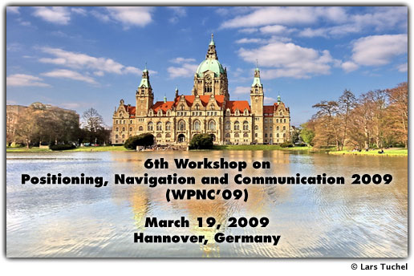

# wpnc

Mobile position aware systems combined with modern wireless technologies are getting more and more important. When developing systems of this kind, problems in various fields of information and communication technology need to be solved. The workshop gives an overview of state-of-the art approaches and systems. As many technologies are available to deal with the variety of applications, we cover ultra-wideband technology as it is becoming of great importance in the area of positioning, navigation and communication.

The Workshop on Positioning, Navigation and Communication 2009 took place in the Leibniz University of Hannover on 19 march 2009.

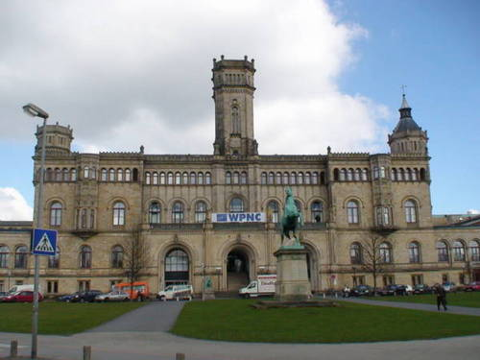

## Ultra wideband session

### A comparison of channel acces concepts for high-precision local positioning

This topic compared two competitive radiolocation systems with FMCW signaling, HPLS and ulta-wideband LPR. They have similar physical layers, so they focused on the medium access techniques utilized by those systems, and their impact on overall system performance.

Each system has specific tradeoffs when multiplexing a number of terminals. The dynamic access scheme employed by HPLS/RToF makes predictions about the update rate dependent on statistical models. HPLS/TDoA imposes no limits on the number of tags that can be served, and the update rate is both real-time and deterministic. Complex synchronization is required.

The optimal solution for each system can only be application specific and fitted to the respective requirements of a given scenario.

This presentation wasn’t really that interesting for our master thesis.

### overview of mac layer enhancements for ieee 802.15.4a

The 802.15.4a standard is suitable for networks using low data rate ultra wideband impulse radio (LD-UWB IR).

The standard IEEE 802.15.4 defines a PHY and a MAC layer, which is extended by standard IEEE 802.15.4a to two alternative PHY layers: a chirp spread spectrum PHY and an UWB IR PHY. This presentation focused on UWB-based PHY only.

They propose different strategies of cross-layer optimizations to the 802.15.4 MAC using features of UWB.

This presentations was also not that interesting for out master thesis.

### hybrid data fusion techniques for localization in uwb networks

This topic exploits the concept of data fusion in UWB localization systems by using different location-dependant observables. They combine ToA and RSS in order to get accurate localization algorithms. The hybrid data fusion technique exists out of two stages: firstly obtaining the range using RSS and ToA and secondly estimating the position by fusion of the estimated ranges. This presentation talked about the path loss log-normal shadowing model of RSSI, which was interesting to our master thesis.

This topic proposed a new ML estimator able to merge smartly different ranges while considering associated variance. The performance is studied using positioning error and Cramer Rao Lower Bound.

## localization session

### a geolocation using toa and foa measurements

This topic describes a geolocation method using ToA and Frequency of Arrival (FoA) measurements. This principle has already been used in GNSS. Most GNSS systems receivers calculate their position based on ToA measurements. By exploiting the additional information of the FoA measurements, a more robust position estimation can be provided.

This presentation wasn’t also that interesting.

### a new localization and accuracy analyzer for wireless sensor networks using defective observations

This presentation presented a simulation tool, named “AccuLoc” (Accuracy Analyzer for Localization in WSN). It tests geometrical conditions, different localization algorithms and measurements in WSNs either in the planning phase or after the localization process. Furthermore this tool enables the detection of outliers, to make accuracy statements and to analyze the determined position.

This tool us useful to formulate statistically-based statements about the accuracy which can be expected and to interpret the geometric conditions when planning a WSN.

### a ranging scheme for asynchronous location position systems

This presentation proposed an asynchronous single-sided two-way ranging scheme which reduces ranging time by replying with multiple packets to a single ranging method. This method reduces ranging time with 17% or more compared to the conventional asynchronous double-sided rang algorithm, SDS-TWR.

### strategies to overcome Border are effects of coarse grained localization

The simplest approach for grained localization is Centroid Localization. In CL, all non-localized nodes calculate their position as the centroid of the beacon’s positions within their communication range, regardless of the distance or signal strength.

The localization accuracy was improved by various centroid-based algorithms, which use approximate distances to improve location estimation through weighting beacons in range, e.g. Weighted Centroid Localization. These algorithms have an increased localization error near network borders.

This topic presents two strategies to reduce the localization error of border area nodes:

* Virtual beacons to rebuild a balanced beacon distribution for border nodes. These virtual beacons compensate for the unequal distribution of beacon nodes around a node near the network border.
* Ignoring beacons which are pulling the nodes position towards the network core

This presentation wasn’t that good: the first strategy to improve the location estimation of the border nodes was poorly explained and doesn’t seem that correct. The algorithms checks which nodes are north, east, south and west. It creates a vector with this information, but you can’t know where each node is or you have to know the location of most of the nodes, but then it isn’t that dynamic.

WCL couples weight to certain nodes for range estimation, they also couple a lower weight to border nodes, so that they are not pulled towards the network core. This is also a solution

## tracking session

### practical indoor tracking using wireless sensor networks

This presentation was about the AIT (Area point Indoor Tracking) system, which uses a serial of RF sensors to track the mobile nodes in the indoor environment. This system depends on RF techniques and has a tracking procedure that is divided into two major steps: area decision and point localization.BCA (Beacon-Correlation Algorithm) and SGL (Shadowing-Grid Localization) algorithms solve the above two steps.

### reducing the complexity order of position estimators with combined radiolocation measurements

This presentation was about minimizing the number of observations that actually take part in the location computation. They propose to linearly combine available measurements into low-dimension observations that lead to the same Fisher Information Matrix (FIM).

This session was quite difficult, because you needed a good mathematical background. And the presented examples were for ToA or TDoA.

## Received signal strength based systems session

### a comparative survey of wlan location fingerprinting methods

Fingerprinting is a method for determining the position using databases of radio signal strength measurements from different sources. This session presented a survey of location fingerprinting methods, including deterministic and probabilistic methods for static estimation, as well as filtering methods based on Bayesian filter and Kalman filter.

This wasn’t that interesting for our master thesis.

### wireless node localization based on rssi using a rotating antenna on a mobile robot

This presentation was about localizing nodes in WSN. It exploits the anisotropy of the antenna gain. The mean error of the position for experimental data is approximately 13 cm.

This method makes use of the directional properties of an antenna to determine Angle of Arrival. No knowledge about the radio properties of the static nodes is required.

## poster session

The most interesting poster was the one of EUWB (European Ultra-Wideband).

Ultra-Wideband radio technology (UWB-RT) enables short range wireless communications with data rates ranging up to Gigabit per second as well as precise real-time location tracking inherently due to UWB’s unique feature of ultra-wide radio frequency band allocation.

UWB-RT provides a minimum of interference to other electronic equipment compared to existing alternative radio solutions. Major European industry sectors are convinced of these advantages and consequently request the introduction of UWB based radio services in their areas.

An industry-led initiative of 20 major industrial and excellent academic organizations from Europe and Israel will effectively leverage and significantly enhance the scientific knowledge base in the advanced Ultra-Wideband Radio Technology (UWB-RT) and will provide sophisticated new applications enabled by UWB and highly demanded in several European key industrial sectors such as home entertainment CE, automotive, public transport, and cellular network

Following this request an industry-led initiative of 21 major industrial and excellent academic partners from Europe and Israel was formed. The resulting EUWB project will effectively leverage and significantly enhance the scientific knowledge base in the advanced Ultra-Wideband Radio Technology providing sophisticated new applications enabled by UWB and highly demanded in several European key industrial sectors such as home entertainment, automotive, public transport, and cellular network.

**Main goals of EUWB are:**

1. Combining UWB-RT with advanced methods of wireless technology such as cognitive signalling, intelligent multiple antenna and multiband/ multimode concepts
2. Applying R&D results to enable the introduction of advanced services and competitive next generation UWB applications
3. Driving international standards and industrial initiatives (ECMA 368/369, ETSI TG31a/c, IEEE 802.15.3c/4a, WiMedia, Bluetooth SIG)

On the image below you see a set up to localizing an object with unknown location.

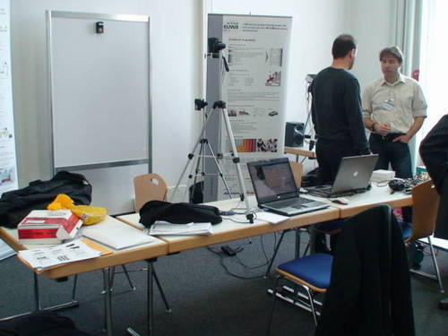

# social event

The people in charge of WPNC also organized a social event to expand your network. The social event took place in a bar/restaurant “Ständige vertretung”. The event has attracted a lot of people, the place was really packed. Unfortunately, the place was so crowded that there was not much room to sit and communicate with other people. Everyone was sitting at their proper table. After 15 minutes we left the place.

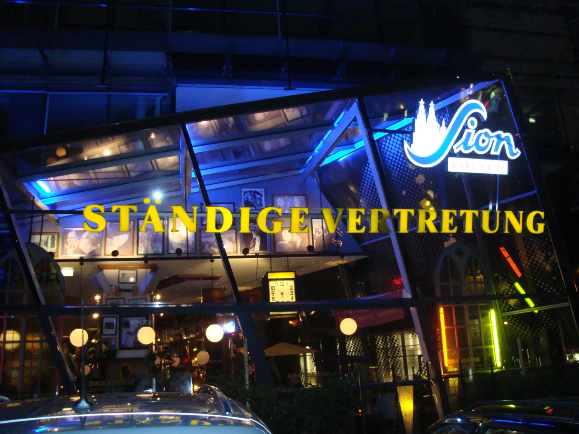

# reflection

We received news from our promoters Jerry Bracke and Maarten Weyn that there was a conference about positioning, navigation and communication (WPNC). We checked this out and this seemed the best conference in the line of out master thesis.

This conference was very interesting and show a lot of novel techniques, but unfortunately the presentation about RSSI weren’t that deep and didn’t really learn much about techniques/algorithms with RSSI.